Happy Birthday Amyyyy!!!

Woo the big 18 :) . Yes so basically I have been dying to say this for like 2 months. Butttttttt I may have spent a majority of my leftover money from cleaning to buy a weekend away to Brighton for just me and you :0 WOOOOOOOO.It actually isn’t a weekend because its on the 26th to the 27th of July which is Tuesday and Wednesday but its one night stillll.

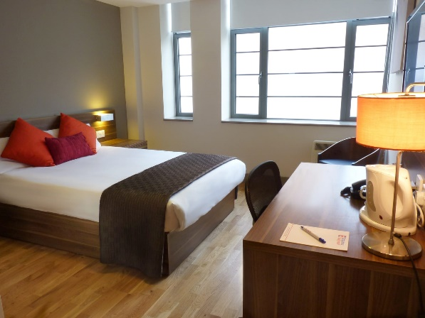So this is the the room that we will be staying in. Its called the Britannia study hotel and its pretty close to the high street.

Looks nice yeah? Good coz it wasn’t free. I will also be driving so it wont cost anything to get there, for you at least :( petrol prices are rough. I will pick you up in the morning so we can go there and spend most of the day there. We can check in at 2pm but otherwise we leave our stuff in my car. We can go to the beach as it’s the summer. Later on in the night we can go out to clubs and bars and we will go out for a meal aswell. Then the next day we have to check out by 11 but I have a parking space that we can stay at until 8pm. So day 2 we can get lunch and go shopping or the beach again. Im so excited.

Anywayy I love you and I Hope you have had a great birthday